**Building ETL Processes (Vendor)**

**Software Requirements Document**

**V 1.0**

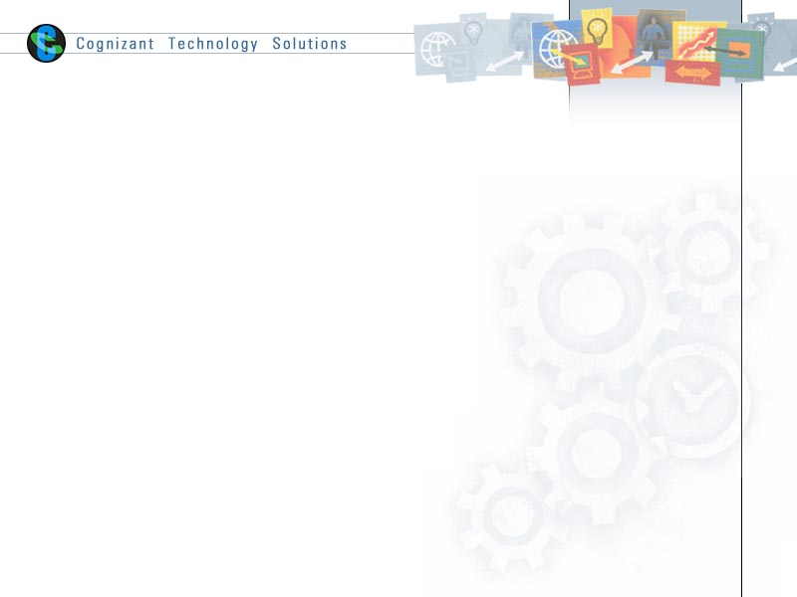

|  |  |  |  |
| --- | --- | --- | --- |
|  | **Prepared By** | **Reviewed by** | **Approved By** |
| **Name** |  |  |  |
| **Role** |  |  |  |
| **Signature** |  |  |  |
| **Date** |  |  |  |

Contents

1 Introduction 3

1.1 About this document 3

1.1.1 Purpose & Scope of the document 3

1.1.2 Intended Audience 3

1.2 About the Software System 3

1.2.1 Scope of the system 3

1.2.2 Exclusions 4

1.2.3 System Perspective 4

1.2.4 Architecture diagram 4

1.2.5 Table Definitions & Mappings. 5

1.2.6 Impact of the System 6

2 System Requirements 6

2.1 Functional Requirements 6

2.1.1 Build data warehouse 6

2.1.2 Build a centralized repository Module 6

2.1.3 Create ETL Processes 7

3 Annexure 7

4 Terms & Conditions 7

5 Appendix 8

5.1 Source file structure 8

5.2 Mapping document 8

5.3 Target creation script 8

6 Change Log 8

# Introduction

## About this document

### Purpose & Scope of the document

The purpose of the software requirements document is to show the usage of the ETL processes in building a Data warehouse specific to business requirements. The ETL tool being used here would be Informatica.

### Intended Audience

Project Team

## About the Software System

The following section will cover aspects related to

We define the scope and objectives, and relate them to the requirements of ABC ltd. This is a good test case to see how a Data Warehouse can be built.

The following are the modules in this proposed system

1. Build the data warehouse.
2. Build a centralized repository.
3. Create ETL Processes.

### Scope of the system

The scope of the system is explained through its modules as follows

* **Build data warehouse** – Client is planning to build a data warehouse of sales, to enhance their decision support. The business requires a centralized data access for generating various reports to forecast and value their product sales across the branches.
* **Build a centralized repository** - A Manufacturing customer has numerous agencies spread across multiple geographies. Customer is deciding on centralized repository of data collection and reporting based on the same. Areas of interests are parts and vendor details.
* **Create ETL Processes** – Our Companies DW Team has won the proposal for the creating ETL Processes to load data into their data warehouse in a daily, monthly, yearly and on-demand basis.

### Exclusions

1. The system will operate only on the modules discussed above and will not include any additional functionality.

### System Perspective

The system is a data warehouse developed to manage the activities like Loading and retrieving data in a daily, monthly, yearly and on-demand basis.

### Architecture diagram

#### Physical Architecture:

A physical architecture is an arrangement of physical elements, (system elements and physical interfaces) that provides the designed solution for a product, service, or enterprise. It is intended to satisfy logical architecture elements and system requirements. Auto Identification Process follows a three layered architecture namely presentation layer, business logic layer and data access layer.

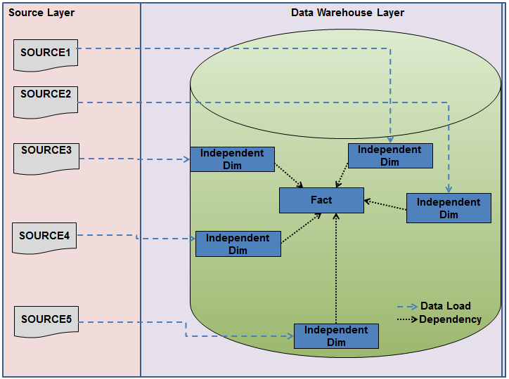

#### Logical Architecture:

The Logical Architecture defines the Processes (the activities and functions) that are required to provide the required [User Services](http://www.iteris.com/itsarch/html/user/userserv.htm). Many different [Processes](http://www.iteris.com/itsarch/html/pspec/pspecs.htm) must work together and share information to provide a User Service. The Processes can be implemented via software, hardware, or firmware. The Logical Architecture is independent of technologies and implementations.

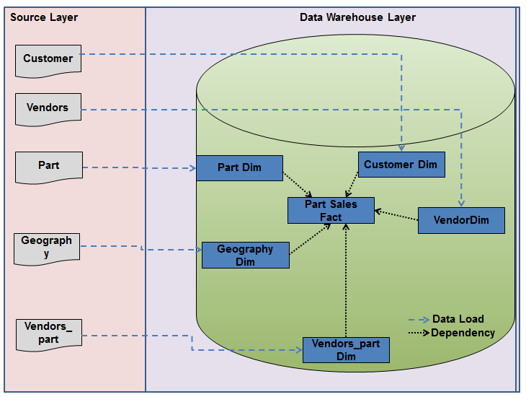

### Table Definitions & Mappings.

|  |  |  |
| --- | --- | --- |
| **Table Name** | **Table Type** | **Table Description** |
| Geography | Type 1 Dimension | **Geography** |
| Vendors | Type 2 Dimension | **Vendors** |
| Parts | Reference table | **Parts** |
| Vendor_parts | Type 2 Dimension | **Vendor_Parts** |
| Customer | Type 1 Dimension | **Customers** |
| Part_sales_fact | fact | **Part Sales Fact** |

### Impact of the System

The data warehousing system is being developed to enhance the decision support and generating customized reports for ABC ltd.

# System Requirements

## Functional Requirements

### Build data warehouse

|  |  |
| --- | --- |
| DW – Build Data Warehouse  Req-2.1.1 |  |
| Functional Requirements | 1. Build a data warehouse for Sales detail Report to provide overall product Sales. 2. It includes net sales, product units, order count, discounts, average order value and average order size. |

### Build a centralized repository Module

|  |  |
| --- | --- |
| DW – Build Centralized Repository  Req-2.1.2 |  |
| Functional Requirements | 1. Centralized Data access is required for generating various reports and data collection from the agencies situated across multiple geographies. 2. Centralized report is required to include net sales, product units, order count, discounts, average order value and average order size. |

### Create ETL Processes

|  |  |
| --- | --- |
| DW – Create ETL Processes  Req-2.1.3 |  |
| **Functional Requirements** | This module will be loading and retrieving the data into the data warehouse on a daily, monthly, yearly, and on- demand basis. |

# Annexure

NA

# Terms & Conditions

GenCs shall be solely responsible for all its acts and omissions under this program. GenCs will comply at all times with all applicable laws. GenCs shall not use Cognizant’s name, logo and trademark in any promotional materials or other communications with third parties without the prior written consent of Cognizant. Any materials used by GenCs in relation to program will not infringe the copyrights, trademarks, patents, trade secrets or other intellectual property rights, privacy or similar rights of any person or entity. GenCs agrees not to post, draw, make, display any content that is threatening, libelous, obscene, defamatory, abusive, pornographic, or advocates/encourages any conduct that could constitute a criminal offence or give rise to any civil liability. Cognizant its associates’ personal details including but not limited to name, address, contact number shall not be shared or forwarded to any third party, without prior written consent of Cognizant, its associates. All intellectual property provided by Cognizant as part of program shall be owned exclusively by Cognizant. Intern shall indemnify, defend and indemnify Cognizant its associates, officers, directors from and against any claims, demands, loss, damage, liability, causes of action, judgments, or costs and expenses of every nature (including attorney’s fees and expenses) incurred by Cognizant based on any claim that any breach of terms and conditions of this program.

# Appendix

### 5.1 Source file structure



### 5.2 Mapping document



### 5.3 Target creation script



# Change Log

Please note that this table needs to be maintained even if a Configuration Management tool is used.

|  |  |  |  |  |
| --- | --- | --- | --- | --- |
| Version Number | Changes made | | | |
| V1.0 | First version developed | | | |
| V1.1 | *<If the change details are not explicitly documented in the table below, reference should be provided here>* | | | |
| Page no | Changed by | Effective date | Changes effected |
|  |  |  |  |
|  |  |  |  |
|  |  |  |  |
|  |  |  |  |
| V1.2 | *<If the change details are not explicitly documented in the table below, reference should be provided here>* | | | |
| Page no | Changed by | Effective date | Changes effected |
|  |  |  |  |
|  |  |  |  |
|  |  |  |  |